18.90: a) 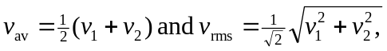 and

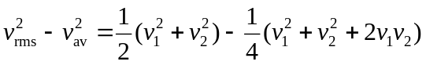

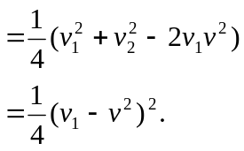

This shows that 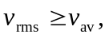 with equality holding if and only if the particles have the same speeds.

b) and the given forms follow immediately.

c) The algebra is similar to that in part (a); it helps somewhat to express

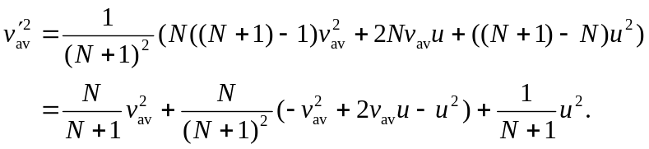

Then,

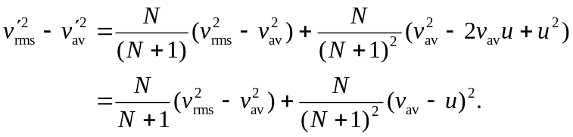

If 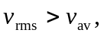 then this difference is necessarily positive, and 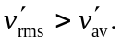

d) The result has been shown for 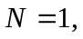 and it has been shown that validity for N implies validity for 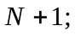 by induction, the result is true for all N.

